Integrated System for Intrusion Detection and Prevention in Computer Networks

B Bhanu Prakash, Kaki Yeswanth,M Sai Srinivas, S Balaji, Y Chandra Sekhar,Aswathy K Nair
Dept. of Electronics and Communications Engineering
Amrita Vishwa Vidyapeetham,
Amritapuri,Kollam.
bhanu_18@yahoo.com,kyeswanth1@gmail.com,venkatasaisrinivas1@gmail.com,balu9198@gmail.com,aswathyscorp@gmail.com

Abstract— In present generation, with the expansion of size of internet, Security plays a crucial role in computer networks. Also with the advancement of Internet of things, earlier technology like firewall, authentication and encryption are not effective in ensuring complete security. This has lead to the development of Intrusion Detection Systems (IDS) which is a process of monitoring events in computer networks which are threats of violation to computer security. With the help of various machine learning algorithms we have carried out the implementation of IDS. Machine learning technique increases the accuracy of anomaly detection in real time scenario. This work focuses on K-Nearest Neighbor (KNN) classifier and Support Vector Machine (SVM) , which classify the program behavior as intrusive or not. To prevent DoS attacks a new method is implemented in this paper. The KNN classified data which provides malicious IP address are blocked in routers through Standard Access-list.
Keywords— Computer Security, Intrusion Detection, KNN

Introduction
Computer security vulnerabilities prevail as long as we have flawed security measures, insecure software programs and weak authentication mechanisms and network protocols. Almost all types of information are communicated and stored in public switched communication network. This may lead to illegal interception, wiretapping and tampering thereby, damage the entire system that results in irreparable loss [11-12]. Security products and Intrusion Detection System (IDS) are the existing methods to tackle the threats in computer networks. The latter is more intelligent as it gathers all the information and study the behavior and based on that it could characterize a programs’ normal behavior [3]. IDS detects network intrusions and protects a computer network from unauthorized users. It helps in distinguishing between bad connections called “Intrusions” and good connections[9]. The distinguishing is done by using different machine learning tools such as KNN-Classification, K-means clustering and probabilistic measures[4]. The term machine learning is a branch of Computer Science that is closely related to data mining. It is a study of algorithms and statistical models to improve the performance of a specific task. These algorithms are used in applications of Intrusion Detection in Computer Networks, spam emails and some other areas where it is impracticable to develop an algorithm for performing the tasks[5-7]. There are many ways in which the machine learns, but the three important ways are:

Supervised Learning
It is the branch of machine learning that maps an input variable(x) to an output variable (Y) based on the labeled training Data. The algorithm is intelligent enough to map the function,f(x) when we have a new input data, x and we could predict the output, Y. As the name implies the supervised learning algorithm acts as a supervisor which teaches the machine using well labeled data and when a new set of data is given as input it could predict the correct output from labeled data.[1][5]

Unsupervised Learning
It is the branch of machine leaning that tests the data which has not been labeled or categorized as in the case of supervised learning. Here the role of algorithm is to classify or group the unsorted data itself based on patterns, similarities or differences [2]. The algorithm has to draw the inference by itself from the data set and because of this such type of algorithm is used in exploratory data analysis.

Reinforcement Learning
It is the branch of Machine learning that works on the principle of feedback of the data given. Reinforcement agent has to learn from the environment and it is bound to learn from its own experience. [10]

There are various issues in intrusion detection that is still needed to be addressed in detail. This paper has adopted two methods. One is to detect the intrusion based on KNN algorithm. To increase the authenticity and reliability of the system a second phase of IP filtering technique is also added.

The paper is organized as follows. Section II describes the methods adopted for intrusion detection. Section III gives the implementation method of the system and section IV discusses results and analysis and the paper is concluded with section V.

methods adopted
Intrusion detection is performed using KNN algorithm which is the simplest one and has less complexity compared to other algorithms. Using KNN classifier, it is able to classify the program behavior in the network as normal or intrusive. The KNN detection system is integrated with IP filtering technique that increases the reliability of the system. In IP filtering method, the system is designed to block the incoming connections which are malicious.

The data set for intrusion detection is obtained from KDD cup99 database which contains a large sample of attacked data set. For KNN based intrusion detection, the dataset is split into training and testing data set using suitable split ratio. Based on the distance between the attributes, the class votes are given with respect to the majority. The Intrusive classes are classified out based on the attributes. After KNN classifier, an IP filtering is performed in the router. We have performed a simulation test network for IP filtering using Cisco Packet Tracer software. In Cisco Packet Tracer, IP address of malicious nodes are listed out and the router is bounded to filter out the malicious connection with the help of Internet Service Provider (ISP). These methods are given in Fig.2.

KNN (K-Nearest Neighbors)

KNN is one of the simplest algorithm used for classification and it is also most used learning algorithm. KNN classifiers need two parameters: K value and threshold value. K value denotes the number of adjacent neighbors and threshold value is used for the judgment of abnormal neighbours. KNN uses the KDD CUP database which contains data points that are separated into two seperate classes to predict the classification of a new data point. The model structure is formed from the data by providing data set along with training data. The KNN was initially executed for random samples in training set and having observed the accuracy, the same was performed on test data. The similarity between the know class and unknown class (unclassified) are dentified using Eucledian distance. Based on nearest neighboring (Euclidean distance) it allocates new unclassified data point to one of the cluster.

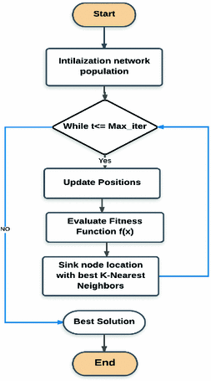
Fig 1. Flowchart of KNN

CiscoPacket Tracer-Blocking Malicious IP Address

Metropolitan Area Network and Malicious IP addressing is implemented in Cisco Packet Tracer. It is a Simulation tool that allows users to create their own network topologies. This software also allows user to simulate the configuration of router and switches using user interface and command line interface.

implementation

KNN Classification
The flow chart for KNN is shown in Fig.1. We have implemented the K-Nearest Neighbour Algorithm with the combination of defining several methods.

1: Importing Data

We have defined a method in Python language to import the data in csv. format. This is for the ease of implementation so that we could extract the dataset smoothly.

2: Classifying the data into Training Set and Testing Set

We have used the split ratio as 0.66:0.33; to split the data, and made use of an inbuilt-function random.random() which returns the next floating point number in the range[0.0,1.0).We have classified the data-set into Training Set if the value of random.random is greater than the
split value.

3: Calculating the Euclidean-Distance

Calculated the Euclidean-Distance by Implementing the Distance formula

4: Extracting the Neighbours based on the ‘K’ value

Calculated distances are sorted and the ‘K’ nearest neighbours are appended in a list. The ‘K’ parameter plays an important role in this method.

5: Extracting the Response from the K-Nearest Neighbours

Based on the majority votes from the neighbours, we return the most up-voted class as the predicted class.

6: Calculating the Accuracy

Based on the ratio of the correct value and predicted value the accuracy is measured.

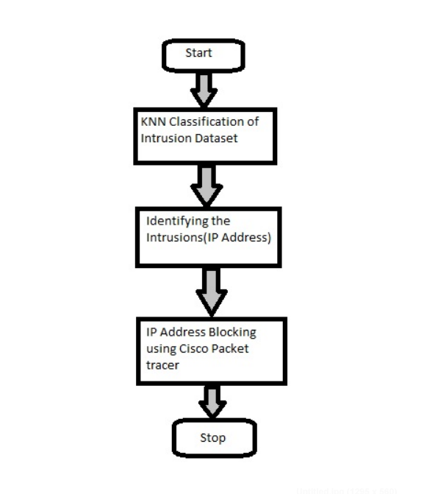

Fig 2. Overview of Intrusion detection and prevention system.

IP Filtering
In this technique, the router will filter out the malicious IP address that is listed in the router local database before the route is announced. This is performed using Access Control List (ACL) that works like filters and deny the packet entering into the network. The ISP (Internet Service Provider) learns the blacklisted IP address that is not delegated by IANA (Internet Assigned Numbers Authority) and based on this router takes the decision for input filtering the malicious IP address.
Establishing MAN in Cisco Packet Tracer using multistep procedure

Assigning IP addresss and Configuration

For proper communication in network, every Personal Computer (PC) is assigned with IP address, Subnet Mask, Default gateway. PC of same network ID are connected through Switch. Switches helps to forward the data between PC’s and it also forwards and receives the data packets of Router. In this step each PC, router and gateway are assigned IP addresses.

Router Configuration

Router helps to communicate between Remote Networks (PC of different Network). PC of one network tries to access web server located at another network , it should communicate through Routers. Every router forms its own routing table so that it provides path for data packet to reach destination. Each router has knowledge of only networks that are connected to it. So, in this step PC’s belong to different networks are connected through routers. Default gateway at PC helps to reach the router it has connected. Also, configuration of router hops is performed in this step.

Connection Establishment.

Step1 and step 2 make successful connection establishment between PC’s of different networks. In this step 3 we are going to check whether receiving data packets of one PC to another are in same network or in remote network through PING command. In cisco packet tracer every PC is provided with terminal. In that terminal ping IP address helps us to know whether proper network is established between them.

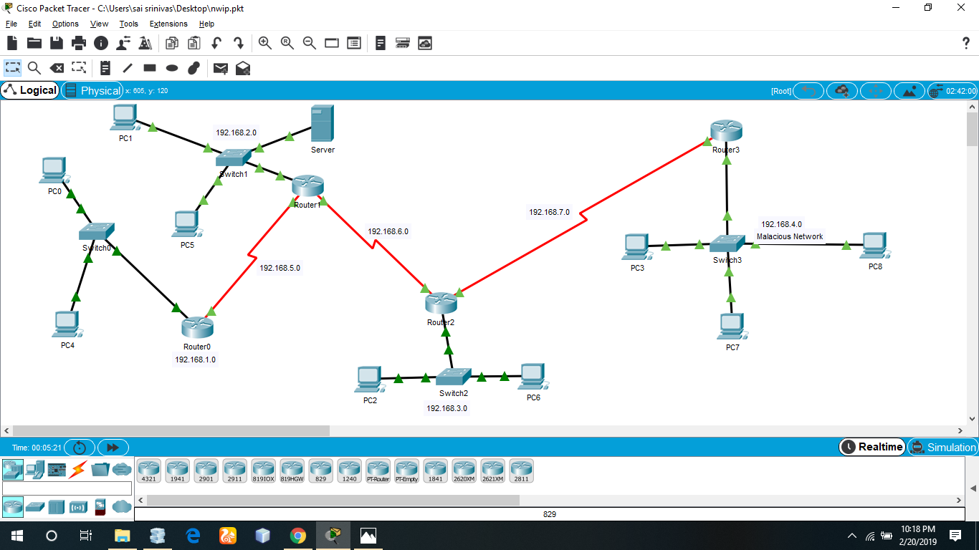

Fig 3. Metropolitan Area Network in Cisco Packet Tracer

Malicious IP address detection

Malicious IP Address blocking using Standard Access list is performed here. In this step PC with malicious IP address are blocked in the router of sever located. Access Control List(ACL) works like filters and enables to control packets that is permitted in or denied out of a network. Every Router in Cisco packet tracer is provided with CLI (Command Line Interface). Commands for denying the ip address in router through standard access list are en helps to enable the router, configure terminal helps us to configure terminal, sh access-lists gives list of access-list created, access-list no deny IP address wildcard subnet blocks the specified IP address the router, access-list no permit any permits all the IP address in network except the blocked IP address.

results and analysis
The KNN classifier was run for different values of K, and for each K, the algorithm studies the network features and anomaly detection. After running the program multiple times, the best K value is chosen that gives less false rate. Simulation result of number of neighbours, K in KNN versus accuracy is plotted in Fig.4.

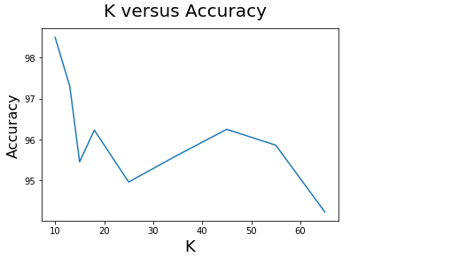
Fig 4. Accuracy versus K-neighbors.

Based on several characteristics and observations, most reliable value of K(Nearest Neighbors ) is chosen. Figure.4 shows the accuracy obtained from KNN which is 89.09 percentage. The screenshot obtained from Python code is given as “accuracy=89.09”.
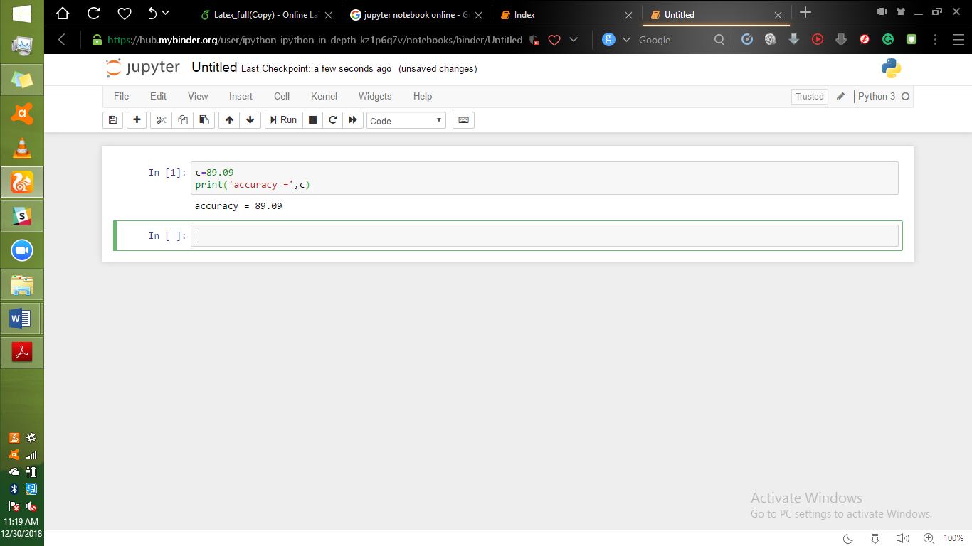
Fig 5. Accuracy report of KNN Algorithm.

The schematic diagram and configuration of a simulation test network using packet tracer is given in Fig.3.

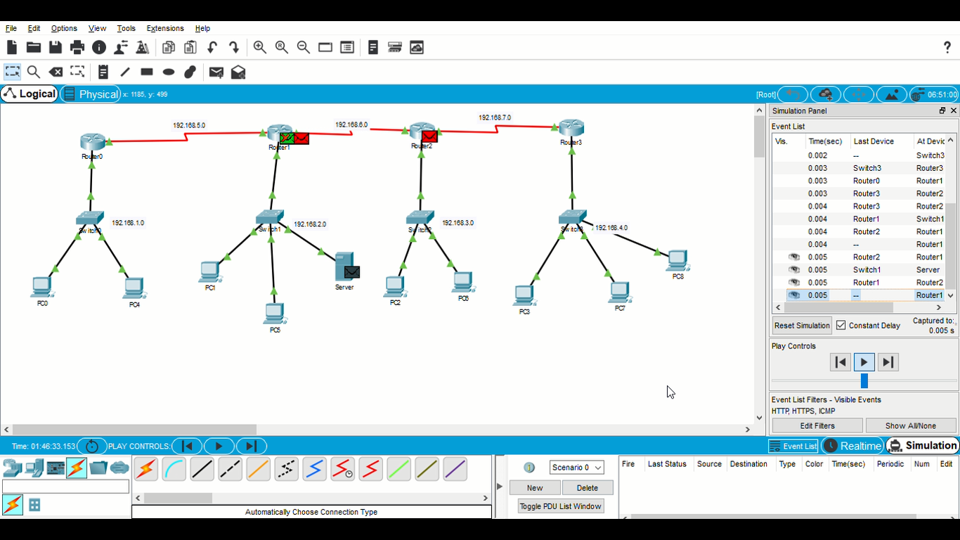

Fig 6. Blocked IP Address denied by router
Cisco Packet Tracer is simulated in a Metropolitan Area Network (MAN). All communicating nodes in Metropolitan Area Network tries to access web server through Routers and Switches which are created in our simulation. So we identify the PC’s with malicious IP address and block those PC’s in Router. Fig.6. shows that connections from malicious node addresses to one of the PC is denied at the router.

conclusion
In this project we have used KNN algorithm for identifying the program behaviour and label as intrusion or not. To increase the reliability of the system, an IP filtering technique is also integrated with the system. Using IP filtering the incoming connections which are malicious are blocked. For experimental findings, we have worked on Denial of Service (DoS) attack. Our results give a good accuracy for intrusion detection using KNN algorithm and decreased false rate. The work may be extended to time stamping method for accuracy and better detection of DoS attack .

References

- Jungatek Seo,Cheolho Lee,Taeshik Shon,Kyu-Hyung Cho,Jongsub Moon ”A New DDoS Detection Model Using Multiple SVMs and TRA”,IFIP 2005.
- EricHutchins,Michael Cloppert and rohan amin from Looked Martin,”Intelligence-Driven computer Network defence informed by analysis of adversary compaigns and intrusion kill chains”, USA,6th International Conference on iwarfare and Security,2011.
- Hanan Hindy,David Brosset,Ethan Bayne,Amar Seeam,Christos Tachtatzis,Robert Atkinson,Xavier Bellekens,“A TAXONOMY AND SURVEY PF INTRUSION DETECTION SYSTEM,DESIGN TECHNIQUES,NETWORK THREATS AND DATASETS”.
- Swati Paliwal, Ravindra Gupta ,”Denial-of-Service, Probing & Remote to User (R2L) Attack Detection using Genetic Algorithm” , International Journal of Computer Applications,2012.
- Ming Zhang,Boyi Xu,Jie Gong “An Anamoly Detection Model based on One-class SVM to detect Network Intrusions”,2015 11th Conference on Mobile Ad-hoc and Sensor Networks.
- Zhang Xiaofeng,Hao Xiaohong “Research on Intrusion Detection Based on Improved Combination of K-means and Multi-level SVM”,2017 17th International Conference on Communication Technology.K. Elissa, “Title of paper if known,” unpublished.
- Kinan Ghanem,Fransisco J,Aparacio Navarro,Jonathan A.Chambers, ”Support Vector Machine for Network Intrusion and Cyber-attack detection”,IEEE 2017.
- Mrutyunjaya Panda and Manas Ranjan Patra, “NETWORK INTRUSION DETECTION USING NAÏVE BAYES” Department of E &TC Engineering, G.I.E.T, Gunupur, India and from Department of Computer Science,Berhampur University, Berhampur, India.
[9] Dr. S.Vijayarani1 and Ms. Maria Sylviaa, Assistant Professor and M.Phil Research Scholar from the Department of Computer Science “INTRUSION DETECTION SYSTEM – A STUDY” , Bharathiar University,Coimbatore.
[10] Fan Yan, Yang Jain-Wen, Cheng Lin “Computer Network Security and Technology Research”, IEEE 2015.
[11] A. U. Prem Sankar, Poornachandran, P., Ashok, A., Manu, R. K., and Hrudya, P., “B-secure: A dynamic reputation system for identifying anomalous BGP paths”, Advances in Intelligent Systems and Computing, vol. 515, pp. 767-775, 2017.
[12] S. Sankaran and Sridhar, R., “Modeling and Analysis of Routing for IoT Networks”, International Conference on Computing and Network Communications (CoCoNet). IEEE, Trivandrum, India, 2015.

